Table 1: Charging & Discharging of an RC circuit.
Maximum potential difference (ℇ) = 6.01 volts

Time (s) | Charging capacitor |  | Discharging capacitor
Time (s) | 𝑉_{𝑐} (volt) | 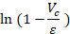 | 𝑉_{𝑐} (volt)
0 | 0 | 0 | 6.1 | 0.015
30 | 1.4 | -0.265 | 4.7 | -0.246
60 | 2.43 | -0.518 | 3.66 | -0.496
90 | 3.2 | -0.760 | 2.84 | -0.750
120 | 3.8 | -1.001 | 2.23 | -0.991
150 | 4.52 | -1.395 | 1.73 | -1.245
180 | 4.64 | -1.479 | 1.38 | -1.471
210 | 4.93 | -1.716 | 1.09 | -1.707
240 | 5.16 | -1.956 | 0.87 | -1.933
270 | 5.32 | -2.164 | 0.69 | -2.164
300 | 5.7 | -2.965 | 0.56 | -2.373
330 | 5.59 | -2.661 | 0.45 | -2.592
360 | 5.68 | -2.902 | 0.37 | -2.788
390 | 5.75 | -3.140 | 0.3 | -2.997
420 | 5.8 | -3.354 | 0.25 | -3.180
450 | 5.84 | -3.565 | 0.2 | -3.403
480 | 5.88 | -3.834 | 0.17 | -3.565
510 | 5.92 | -4.201 | 0.14 | -3.759
540 | 5.94 | -4.453 | 0.12 | -3.914
570 | 5.96 | -4.789 | 0.1 | -4.096
600 | 5.98 | -5.300 | 0.09 | -4.201

Calculation: Charging a capacitor
Theoretically:
Time constant, 𝜏 = 𝑅𝐶
= 47×10³ ×2200×10⁻⁶ =103.4
Experimentally:
From the graph: Slope, m = 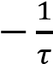
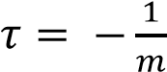 = -1/(-0.0083) = 120.48

Error of 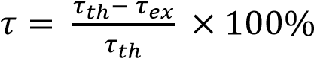 = (103.4-120.48)/103.4 × 100% = 16.52%
Calculation: Discharging a capacitor
Theoretically:
Time constant, 𝜏 = 𝑅𝐶 =103.4
Experimentally:
From the graph: Slope, m = 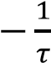
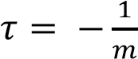 = -1/(-0.0071) = 140.85
Error of 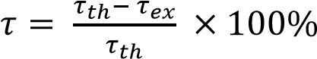 = (140.85-103.4)/ 103.4×100% = 36.21%

